Ideation document

Name: Tifrea Andrei
Git rep: https://git.fhict.nl/I455422/individual-assignment.git

Description

I decided to create a website and application for a renting ski resort shop where people can come and choose and decide which equipment fits them best to get the finest day in the ski-resort. Overall the website will be for customers that would like to make a reservation for equipment and an application for employee management and stock (equipment) management.

Wireframes

Home page (can be seen by both admin and normal users and it will have the same nav bar as other pages) :
Here there will be displayed the available equipment with a rating and description that has some info about it.

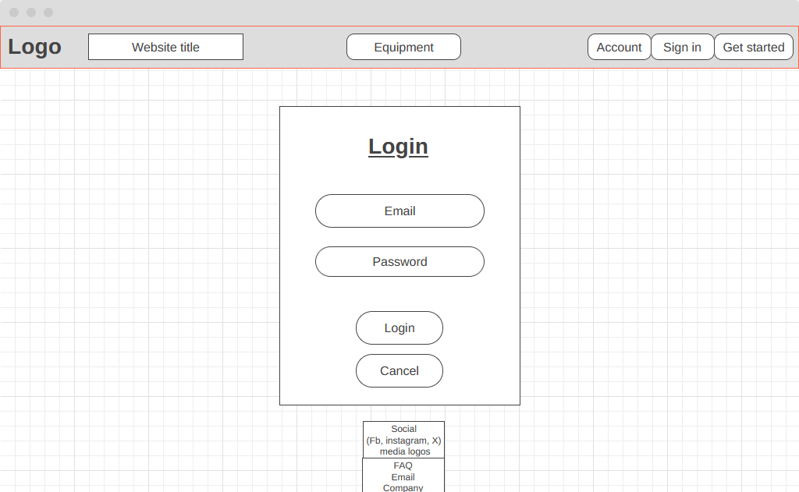
Login:

Register:

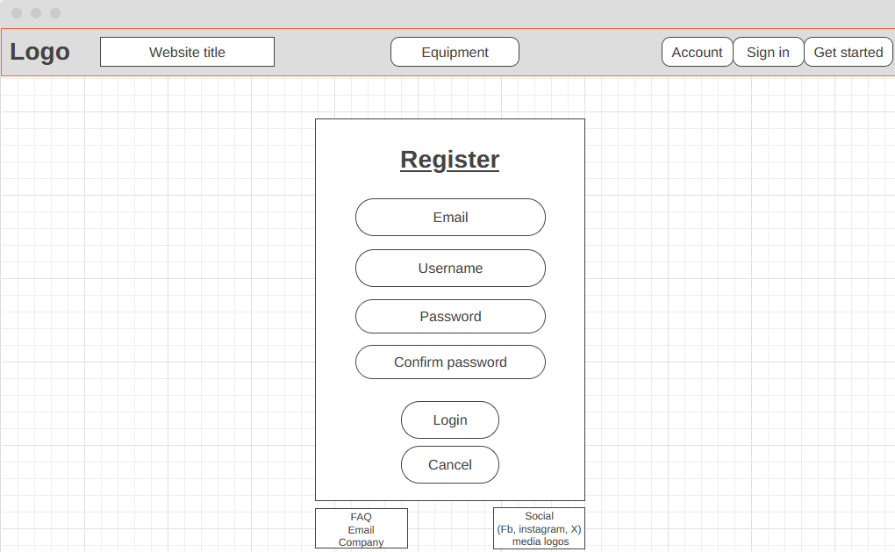

List of the equipment:
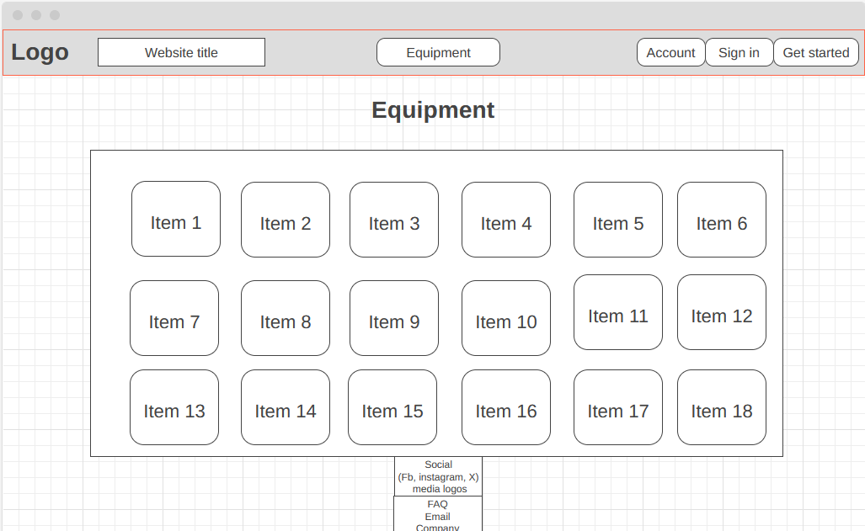

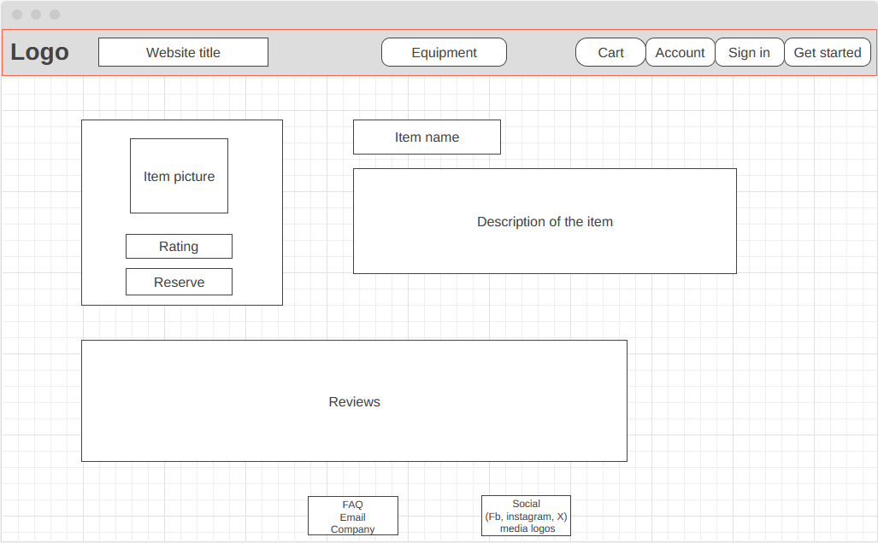
Item description:

Homepage:
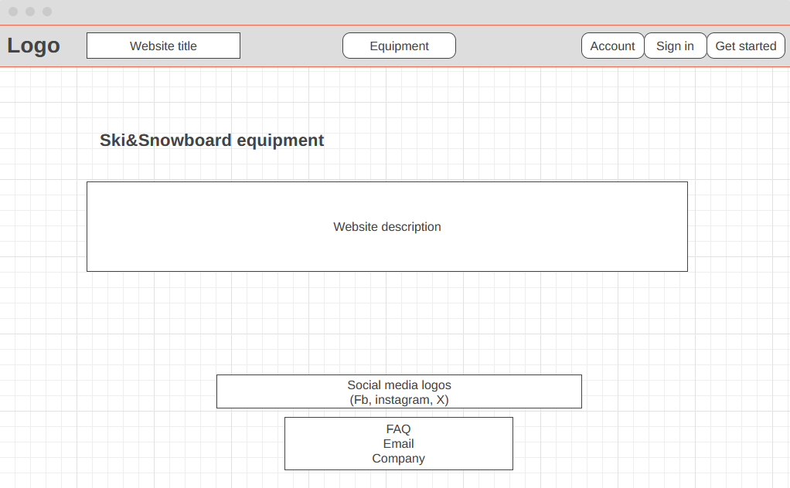

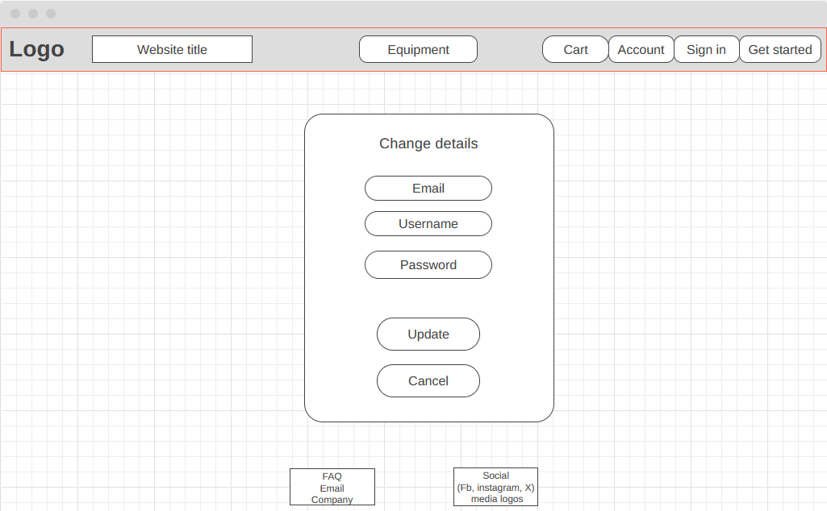
Change details:

Reservations:

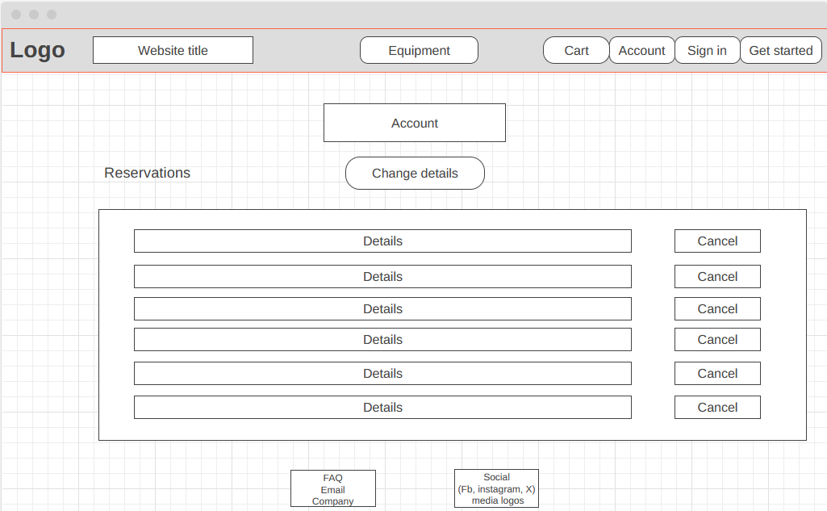

Colour Pallete

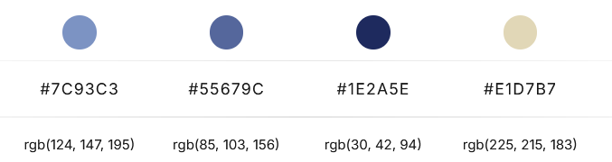



Sitemap

Homepage
Overview of services, available equipment, special offers, etc.

Login page
Users can log in to view their reservation history, account details, or make new reservations.

Register page
Allow users to create an account with basic information like name, email, and contact number.

Contact/Information Page
For inquiries and customer service issues.

Equipment reviews
Allow users to create reviews for the equipment rented.

Account
This will give logged-in users access to their profile information, reservation history, and the option to change personal details.
List of the equipment
This is where users can browse the equipment.

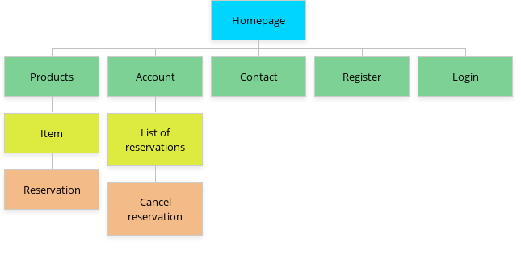

Users

Administrator (Admin):
- CRUD for equipment: Create, Read, Update, and Delete equipment data (name, type, stock, pricing, etc.).
- View and manage all reservations: Admins should have access to a dashboard that shows upcoming and past reservations
- Manage Users: Admins may need to ban users or adjust user privileges.

Normal User:
- Create an account: Basic functionality for all users.
- Create/cancel an appointment: Users should be able to book equipment for a particular time and cancel their booking if needed.
- View reservation history: Users should have access to their past and current reservations.
- Leave reviews: After using the equipment, users should be able to rate the equipment and leave a review.

Flowcharts

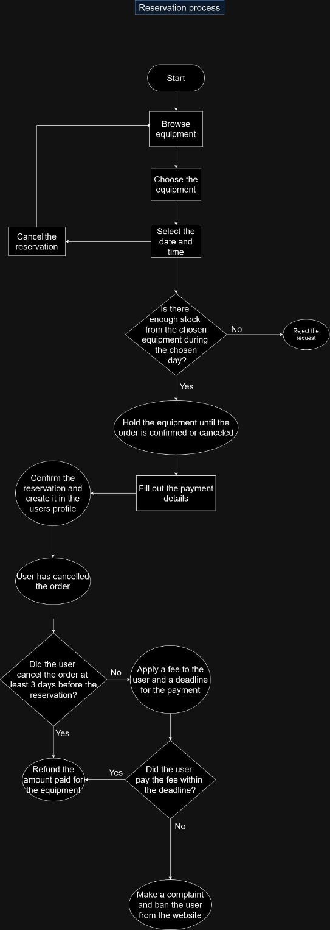
Reservation process

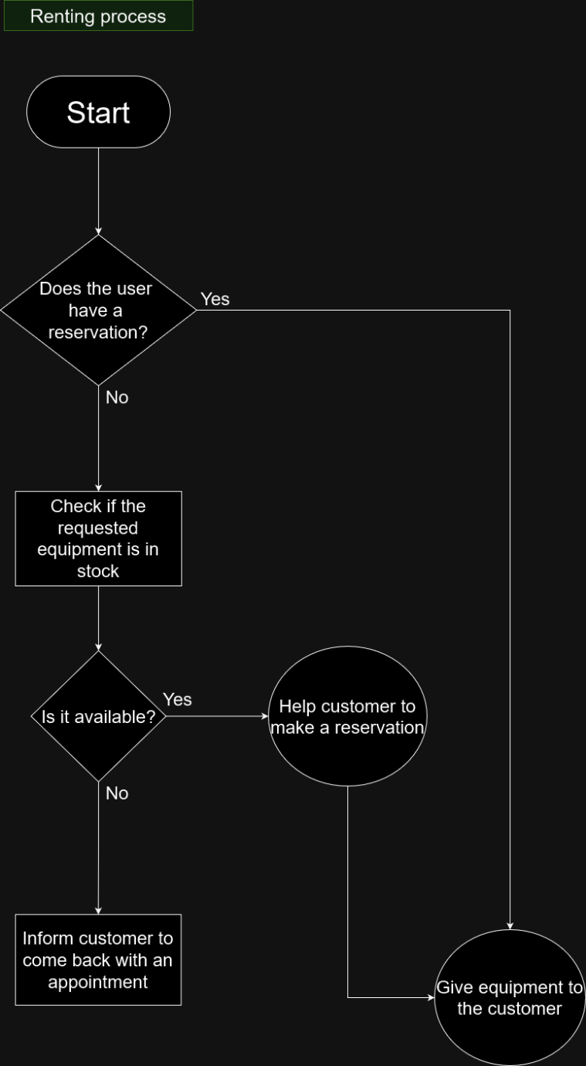
Renting process

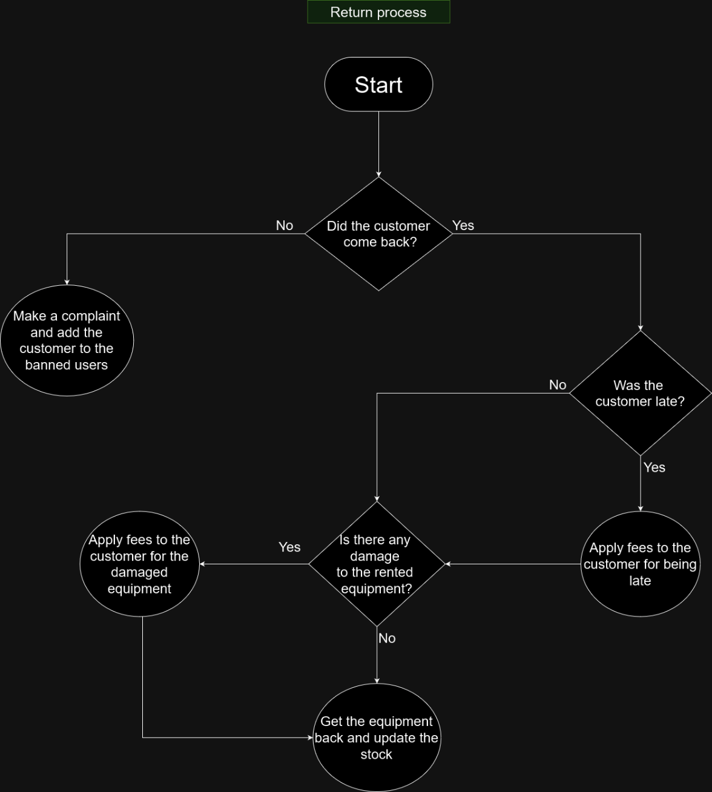
Return process

